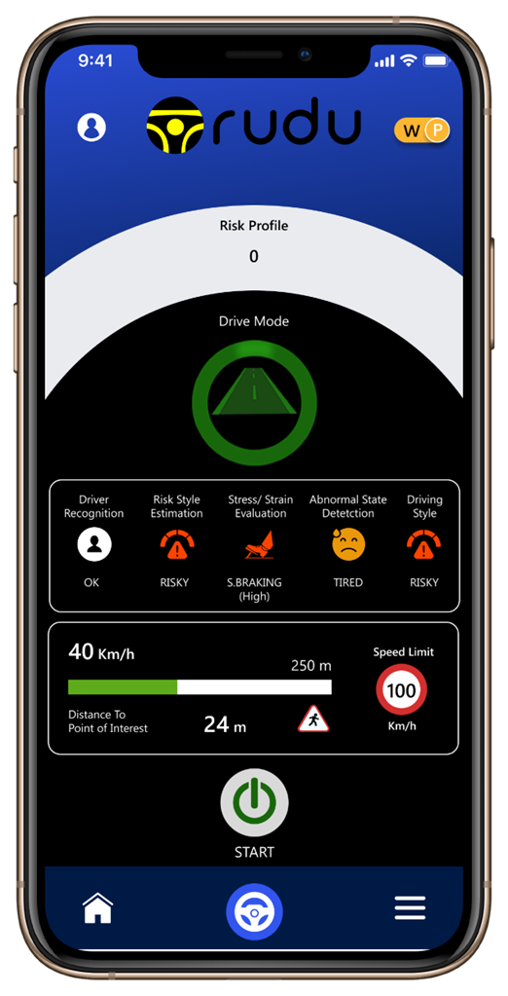

“I Drive Well, the Problem is the Other Driver”: A Study About the Self-Assessment of the Ability to Drive

Applies to Car/Truck/Bus/2Wheelers/3Wheelers

“The fact that human beings make erroneous estimates of their own ability to drive motor vehicles may have important safety implications. Thus, assessment of own driving skills is as important dimension of road risk management and can be of fundamental importance in both, reducing the likelihood of an accident and increasing safety in driving.”

Positive self- assessment can have diverse consequences. However, the overestimation of one’s driving ability is probably more dangerous than its underestimation, because it may increase a risky driving behaviour

Furthermore, overconfidence among drivers makes them less likely to adapt their behaviour to traffic situations, leading to even more violations of traffic rules. The question of overestimated driver’s self-appreciation also reflects the impact of traffic safety campaigns: why people who overestimate their skills should pay attention to the instructions given to drivers in general since they are safe and drive better than other drivers.

Hence such drivers do not seem to identify themselves as requiring instructions, because they believe that campaigns are aimed at drivers who are not so skillful and who are not as protected as they think they are. The ability to drive is related to the level of knowledge and skills in traffic, as well as processing information and performance in different driving tasks, as maneuvers, detection of risk, etc. therefore the subjective measure of general driving ability can be related to the measure of real driving capacity.

“What does it mean to drive well, outside of any emergency situation?”

This question was initially asked by insurers and driving psychologists, and it is now coming to cars/trucks/2wheelers manufacturers to offer non-emergency driving assistance systems.

The idea of reformulating this question from perspective of prudence and have chosen to estimate in real time level of caution (or prudence) of a driving behavior regarding context. Notion of context is essential and is used to define prudence as ‘the adequacy of the behavior to the context, without necessarily knowing the whole context or all the possible consequences of a behavior’.

The approach seems to be more operational than that consisting in seeking to know the whole context and knowing how to predict consequences of any action, an approach which is somewhat the philosophy of a lot of work on autonomous vehicle.

Unfortunately, this last solution obviously leads to vehicles overloaded with sensors and to road infrastructures that are overpriced (since we have to know everything), and to increasing on-board computing power (since we have to understand everything), putting the fruits of this work out of the market because it is too expensive.

Such an approach can only be applied to public transport systems, since the purchase or rental of such a vehicle is not an option. It is still necessary that the flow of people transported make it possible to make investment profitable over an acceptable period, which is not yet the case to date.

‘If I am bad on certain criteria and good on others, it is possible that I am average overall’

‘Unfortunately, what some drivers do, they commit incautious acts but do not have an accident or even a bad surprise, and they take on bad habits in terms of road safety’

Prudence consists, in acting in anticipation of potential surprises, without knowing everything about context. From this definition, we define the notion of risk as being lack of prudence.

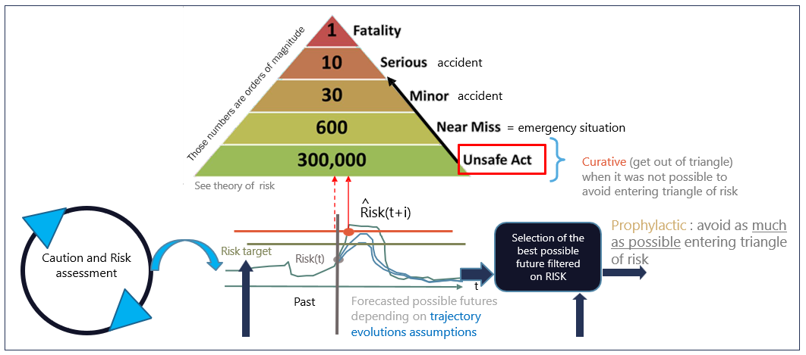
If the driver commits to an imprudence, and this does not lead to consequences most of time, but rarely this recklessness leads to near-miss situation or emergency situation, for which accident is avoided most often, Finally, some accident occur, of which a small part is serious and an even smaller part is fatal.

Level of prudence (or caution) estimated by our AI can be considered in a way as a “distance” to the risk triangle, with entry into the triangle (unsafe act) when prudence is too low (or when ‘lack of prudence’, called ‘risk’ is too high).

Detection of entry into risk triangle, and action for a rapid exit: “undo unsafe act”

Continuous monitoring of the value of risk so as never to enter, when possible into risk triangle, to do this, we define a maximum authorized risk (lower than the high risk which corresponds to entering triangle. The risk is referred to as ‘risk target’. If we manage not to exceed risk target, then we don’t enter into risk triangle and we do not commit an unsafe act. This is the second level of anticipation.

Note: Conditions on real roads may be complex, and sometimes it is not possible to avoid entering triangle, for example, vehicle should slow down to stay prudent but a crazy vehicle appeared behind and may hit rear of the car if braking is done at right level, this idea is to be aware of it and if obliged to enter triangle, then find a quick way to exit

Safety coach / Digital Copilot

Since lack of caution (risk) is calculated 20 times per second while driving, this information can be used to help driver avoid emergency situations as much as possible: for this, as soon as value of risk exceeds the threshold for entry into risk triangle (detection of an 'unsafe act'): a visual, audible or haptic interface informs driver who then becomes aware that it would be great to return to a safer driving behavior.

In the aftermarket applications that deploy this solution for insurers and fleet managers, driver can thus choose when to be informed before entering risk triangle, which brings as we explained before a second level of anticipation.

As described previously, one of the outputs of our AI is an abacus of iso-risk curves between present position and the position of rupture on the pathway.

Example of an abacus of iso-risk curves when approaching a STOP sign:
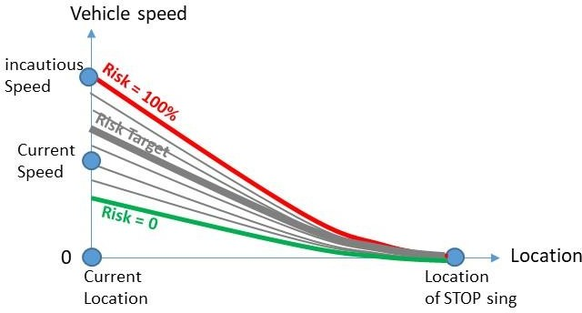

Ideally, driver should modulate vehicle speed to always stay between ‘risk = 0’ curve and ‘risk target’ curve. Each time he/she crosses 'risk target' curve, he/she can be informed.

If one drives at constant speed in this set of curves, one crosses all curves of the chart up to the 'risk = 100%' curve which one reaches before the location of STOP sign (anticipation), which corresponds to an increase in risk:

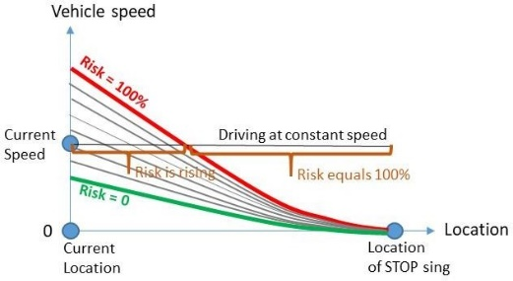

On this figure, one can see that if driver stays at current speed, risk will rise and go upper risk target : those curves tell when and how to slow down.
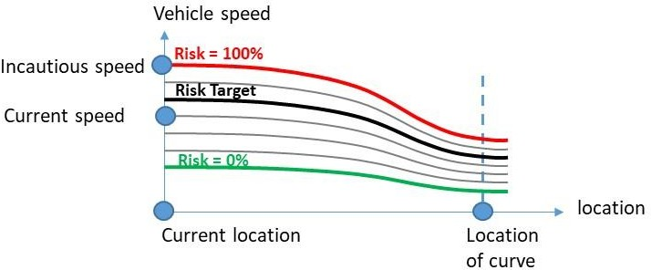

Functional safety: on-board computing of risk of accident

Safety estimation is of utmost importance for in the perspective of fully automated vehicles. In particular, recent progress on accident estimation measurement made by insurance companies has revealed that correlation-based considerations do not give satisfaction.

Indeed, there is no correlation between accident data bases and data collected by accelerometers such as the so-called “severe braking” that was supposed to estimate anticipation of the driver and thus a “risk of accident”.

More recently, it has been demonstrated that accidents are rare events being the consequence of the repetition of “near- misses” accidents (e.g. a Quasi-Accident). It has also been shown that there exists a causality relationship which fully explains “near-misses” accidents.

A Solution for measuring the On-board risk of accident

Observatory of trajectories goal is to observe, record and count the “near-misses” accidents, by assuming that an accident cannot be predicted. An accident is rare: the reflexes of the driver and the other road users, the circumstances, the luck, etc,…usually allow to avoid the accident to happen.

A near-miss accident is the expression of a high risk, statistically speaking, and the probability for an accident to happen increases with the repetition of near-miss accidents. However, the question under which circumstances a near-miss accident turns into an accident cannot be answered by causality relationships. It is only statistical. On average, an accident is the consequence of the accumulation of 100-1000 near miss-accidents (1). Fig 1 depicts an illustration of this fact.

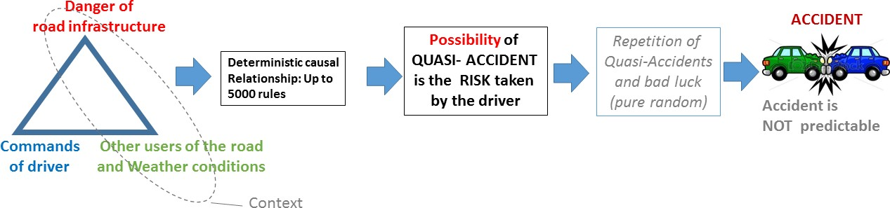

Fig 1

The notion of near miss accident is very interesting. Indeed, if one can compute a real time risk function, then one can assess the risk taken by the driver at all times. If the considered car/any vehicle happens to be in risk too often, there is a high probability it will end up having an accident. Hence, having an indication of the risk at real time can be used to control the car.

Based upon results discussed above, our software which allows to estimate the driving style and its relevance regarding the road environment, in real time, and assigns a risk score (score usually presented in reverse: Safety) correlated by construction to accident.

Our Software is a knowledge-based engine, with more than 5000 rules, using “possibility theory” and its implementation into fuzzy sets theory. In the current state, this engine takes the dynamics of the vehicle (acceleration and speed) and an Electronic Horizon (HE) as Inputs.

The EH is obtained from map matching algorithms, and it corresponds to the most probable driving path in front of the vehicle. A dimensionless quantity 𝑟 ∈ {0; 1} is the output. It gives an estimation of the risk at real time: if 𝑟 = 0, the risk does not exist, if 𝑟 = 1, the risk is high and a “near miss” accident is detected.

Thanks, to the Electronic Horizon, this solution is also able to obtain a “risk profile” as a function of the distance along the most probable driving path in front of the vehicle. It is thus possible to fully anticipate the risk in the future considering the current behavior of the vehicle.

Results and Discussion of validation tests

Safety measurements have only been made by analyzing data collected from accelerometers so far, by assuming that a “severe breaking” (important acceleration variation) reflects a lack of anticipation, and thus, an unsafe behavior.

The variation of acceleration is also assimilated to the Eco driving attitude (Fuel consumption is related to acceleration variations). Hence in the severe breaking assumption, the safety is directly correlated to the Ecological driving attitude.

We have imagined four different scenarios to highlight the most common driving behaviors:

The “Good” driver
The “Quiet – dangerous” driver
The “Bad” driver
The “Expert Sportive” driver

Driver profiles for those four scenarios are the following:

The “Good” driver does not accelerate much and has a good anticipation when approaching a Dangerous Point of Interest (DPOI).

The “Quiet – Dangerous” driver does not accelerate much but does not stop at all when approaching a DPOI.

The “Bad” driver accelerates very often and strongly and does not slow when approaching a DPOI.

The “Expert Sportive” driver accelerates very often and strongly but slows down when approaching a DPOI.

Each scenario has a duration of about 90s, following the same journey of 1,5 km. The Journey, driven by a professional driver, was mostly composed of traffic lights, pedestrian crossings and intersections, representing a typical journey in an urban environment.

To measure the impact of the individual driving attitude regarding the vehicular energy efficiency (“eco attitude”) when executing those scenarios, this module takes the acceleration and standard GPS frames as inputs. Then this software engine analyses acceleration signals following ten different rules and it outputs a dimensionless quantity varying from 0 to 100% which quantifies the eco driving style (“eco attitude”). The combination of the two modules allows obtaining point clouds in the Safety - Eco Space by collecting data at every second.

Point clouds in the Safety - Eco space (scale in percent) for those fours scenarios are given in Figure 2.

One can see that for the “Good” driver case (2.A), points are only confined in the green area, with safety values varying between 100% and 50%, and the Eco values are always around 70% and 75%, which corresponds to a good Eco attitude: the driver has a global safe and an eco attitude at the same time.

In the “Quiet Dangerous” driver case (2.B), safety values vary between 100% and 0% and Eco values are around 70% and 75%.

In the “Bad” driver case (2.C), points spread all over Safety and Eco range, with a rather important number of points confined in the red area: the driver has a global unsafe and wasting attitude

Finally, in the Expert Sportive case (2.D), most of safety values are found between 100% and 50%, with a few of them below 50% though. Eco values otherwise vary between 70% and 0%.

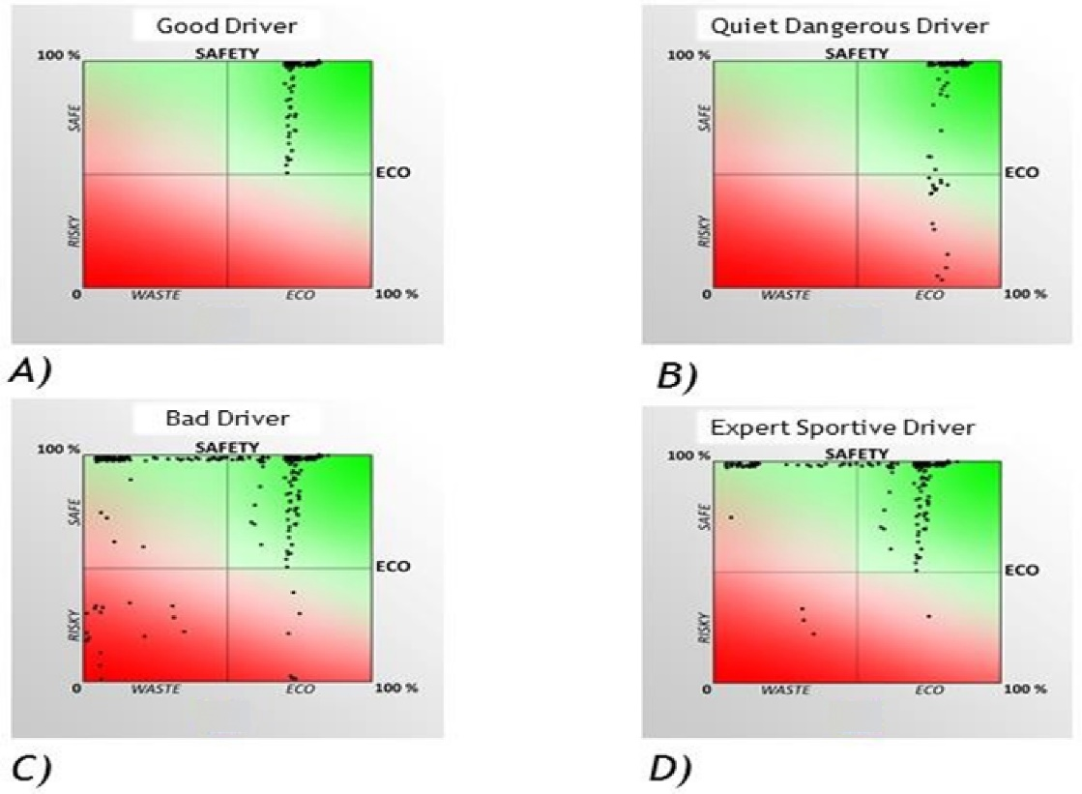

Figure 2
Let us discuss the “Quiet and dangerous” and the “Expert Sportive” driver cases.

For the first case, the driver generates dangerous situations because he never slows down when approaching a DPOI, but has a good Eco driving attitude (the driver does not accelerate much, and keeps a relatively constant speed).

Hence, as an example, if the driver approaches a pedestrian crossing, he does not slow down to anticipate the presence of a pedestrian who would suddenly appear. So even though it has a good Eco driving signature, the driver is dangerous, which contradicts the idea that a good Eco driving attitude is necessarily safe.

Hence, there are in general no correlations between safe and ecological driving styles. This is visible from a formal point of view when observing the cloud point in the Safety - Eco space: one cannot fit the cloud point with a linear curve passing at the origin and having a slope “one half”.

The Expert Sportive driver case, in the opposite, does not generate dangerous situations most of the time, even if his Eco driving attitude is very bad (the driver accelerates and breaks very often and rather strongly).

Conclusion

We show that our approach is more appropriate to estimate the real safety level than accelerometers and the so called “severe breaking” assumption.

In particular, by studying four different driver profiles, the “Good”, the “Bad”, the “Quiet Dangerous” and the “Expert Sportive”, we show that safe and ecological driving styles (measurement of acceleration variation) are not correlated.

Hence, the “severe breaking” assumption falls down. This is particularly visible for the case of the “Quiet Dangerous” driver. Indeed, the driver does not accelerate (Good Eco score), however he does not slow down when approaching a dangerous area (Bad Safety Score) but passes through it at constant speed.

Upon the “severe breaking” assumption, the diver would be given a good score, whilst he is clearly dangerous. This is a clear illustration of the fact that the “severe breaking” assumption is not appropriate to measure real safety level.

As a further extension of our solution, weather conditions and the grip of the road could be added to inputs. The risk estimation could be also improved by adding a camera in order to merge signals obtained from the road/obstacles detection in front of the vehicle.

Finally, in addition to an autonomous car, this solution can be used either for making data-based services richer or for a more relevant estimation of safety level and a better accident anticipation for any type of vehicles e.g. by the insurance sector.

Features Description

Traffic Score
Driver Recognition
Abnormal State Detection
Transport Mode Recognition
Stresses and Strains Evaluation
Driving Style and Risk Style Estimation

Traffic Score

Frequency: Calculation @ 20Hz so each time the acceleration are refreshed. At the end of the trip an histogram of the different modalities during the trip is calculated

Description: Estimates if the traffic conditions. This is made with a comparison between current speed and average speed with a filtering to not take into account all the areas where it is normal to slow down or stop. The decision is made by a static Algorithm

Data used: current speed, eHorizon

Use of remanent data: No

Output: the output can take 3 values (Fluid, Slow, Stopped and unknown)

Driver Recognition
Frequency: Calculation per trip.

Description: The driver monitoring engines calculates a driver signature during the trip, in order to recognize a driver. This is made by using an unsupervised learning made @ the end of each trip (or during trip). This learning decides if it is a known driver and which one (index) or a new one.

Data used: Speeds, Accelerations, Jerk and Risk

Use of remanent data: yes

Output: an identification number or unknown

Abnormal State Detection
Frequency: Calculation @ 20Hz and at the end of the trip

Description: The driver monitoring estimates during a journey if the driving is normal (for this driver) or not. And then if not normal we figure out the style in order to find if the driver is angry or tired. This is made by the comparison between current driver signature and the driver Signature at the beginning of the trip. The evaluation of the current state of the driver is made by a neural network. The abnormal state detection is made by an unsupervised learning neural network.
Data used: eHorizon, Speeds, Accelerations, Jerks and Risk

Use of remanent data: Yes

Output: Normal, Tired, Angry and Unknown



Transport Mode Recognition
Frequency: Calculation @ 20Hz and resume at the end of the trip

Description: Software estimates the transport mode from the acceleration and GPS sensors, to know if the phone is in a car or not. The decision is made by a specialized neural network and a static Algorithm.

Data used: Speeds, Accelerations, Jerk, eHorizon

Use of remanent data: Yes

Output: Car, Walk, Bike, Unknown

Stresses and Strains Evaluation

Frequency: Calculation @ 20Hz and resume at the end of the trip

Description: The driver monitoring engine uses the current Accelerations and Jerks signature to evaluate the levels of stresses and strains made by the driving style. We estimate a braking level, a severe cornering level and a severe acceleration level. The evaluations are made by a static Algorithm

Data used: Accelerations, Jerk and eHorizon

Use of remanent data: Yes

Output: Severe braking level (low, medium, high, unknown), Severe cornering level (low, medium, high unknown), Severe Acceleration level (low, medium, high, unknown)
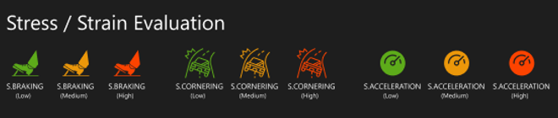

Driving style and Risk style estimation

Frequency: Calculation @ 20Hz and resume at the end of the trip

Description: The driver monitoring engine uses the current Accels and Jerks signature filtered by the eHorizon to evaluate the driving style and the risk style. For the driving style the classification is made by a trained Neural Network (this neural network was learnt using driving signatures from a panel of drivers). The risk style is made by classification rules.

Data used: Accelerations, Jerk and eHorizon

Use of remanent data: Yes

Output: Driving Classification in 4 classes (sportive, aggressive, chaotic, normal, eco, and unknown) and Risk classification in 3 classes (Anticipative, Expert, Risky, and unknown)





It will contain login-based specific & secured information about:
Road User details:
Their Driving License Safe Driving Scores, the validity of the license, insurance policy, e-challan & penalties if any,
Vehicle details:
Registration, challan, PUC, vehicle insurance, Commercial Vehicles permit, e-challans & penalties etc.,
Road/Highway details:
Road geometric, real-time information about black/grey spots, potholes, riding quality index, signages, etc.
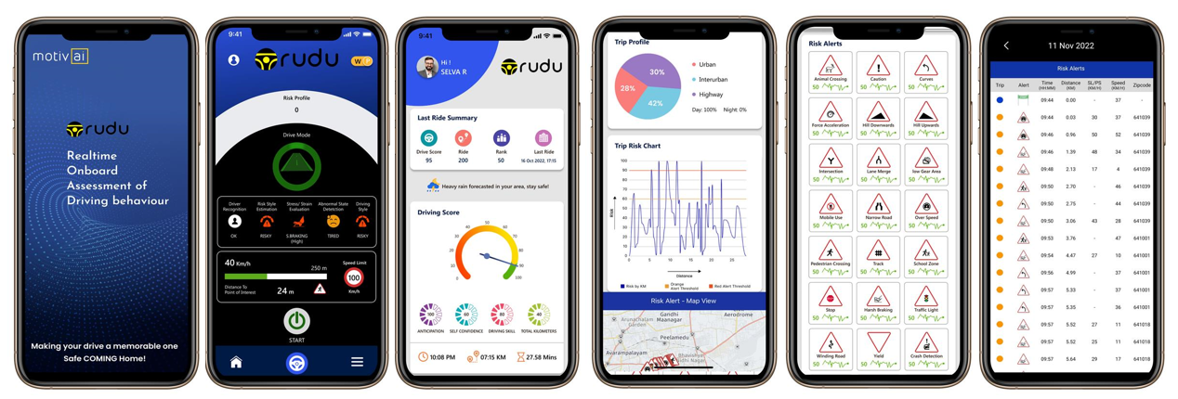

The Electronic Horizon

Introduction

The aim of this paragraph is to:
Describe the notion of Electronic Horizon (EH) which is necessary to operate the RUDU Module.
Specify the necessary entities and objects for constructing the EH.

1.2 Description of the Electronic Horizon

The EH in front of a vehicle is given by map matching (the most probable path or predicted route) using the current coordinates of the vehicle.

This EH is a polyline and it’s formed by a set of segments from 1 to N as described in figure 1.
Every Segment must have a fix direction either positive or negative: the beginning of the segment N is corresponding to the end of the segment N-1, and the end of the segment N coincides with the beginning of the segment N.

The notion of segment and the information related to it will be explained in detail later in this document.

The polyline representing the most probable path must be spread as far as possible. In some cases, like in rural areas or on the highway, the EH can be very long (tenth of kilometers sometime).

Thus, to minimize the time of retrieving the information, it is necessary to define a maximum size that the EH cannot exceed.

In case of an intersection, the EH will spread over the next segments if the latter belong to a lower-level way category (primary, secondary, tertiary...).

However, at a certain intersection it is possible that the EH stops when there is an incertitude about the road to take: this situation is possible when the outgoing segments at the intersection have the same level of priority as the incoming segments.

Finally, when the vehicle outreaches the end of the EH, this latter must be recalculated by map matching regarding the new path taken by the vehicle.

Figure 1: Schematic representing the polyline (in red) corresponding to the most probable path

Specification of the segment

A segment is an extensive description of a parcel of the road, this description contains characteristics like speed limit, length, type of environment, type and category of the way.

In addition, a segment had a start, an end, plus a number N of intermediary points as in figure 2. Hence, two intermediary points form a “sub segment” and a segment is a set of sub segments where the heading can change. A sub segments is necessarily straight whereas a segment can have different shapes.

The exhaustive list of the segment attributes is described by the following:
Segment « ID »
Length (in meters)
Segment Speed Limit (in Km/h)
Number of lanes in vehicle direction (*).
Number of lanes in negative direction (*).
Environment (Urban or Not Urban)
Way category (Primary, secondary, tertiary…)
Way type (Pedestrian, roundabout, slip road, other, motorway)
Slope (in %)
Number of sub segments
List of sub segments
Number of connected segments at the end of the segment
List of the connected segments
Number of the traffic signs on the segment
List of the traffic signs on the segment including those at the limits of the segment (**)
Where the List of sub segments attributes is:
Latitude/Longitude of the beginning of the sub segment
Latitude/Longitude of the end of the sub segment
Distance between the beginning and the end in meters
Heading regarding the North-South axis (in degrees) (***)

And the List of the traffic signs attributes is:

Type of traffic sign
Latitude/Longitude of the traffic sign
Side (left/right or unknown)
Type of vehicle

Figure 2: Schematic representing a segment

It is important to note that RUDU needs to know the distance that separates the traffic sign or the intersection from the vehicle. RUDU has to recover the distance (in m or km) that separates two successive coordinates.

The API must contain the necessary procedures that help obtaining this distance. In addition, the set of segments must be sorted (the first segment corresponds to the segment where the vehicle is and the last segment corresponds to the end of the polyline) and the segments must be oriented toward the same direction. The same rules are applied for the set of sub segments. However, there are no specific rules for the traffic signs.

(*) Notion of direction negative and positive:

The positive direction is toward the end of the segment, on the contrary the negative direction is toward the beginning of the segment.

(**) A traffic sign can be located at the frontier of a segment. Thus, the traffic sign located in the end of a segment is also located in the beginning of the next segment (figure 2).

(***) Notion of Heading:
Angle oriented clockwise between the South-North axis and the vector defining the sub segment as depicted in figure 3. A sub segment which is collinear to the S-N axis and oriented in the opposite direction has a heading of 180 degree, whereas a sub segment which is collinear to the S-N axis and oriented in the same direction has a heading of 0 degree.

Figure 3: Schematic illustrating the notion of heading
